**Ontology-based Expert System for a Generic Drug Production of Pharmaceutical Dosage Forms**

Project Proposal

By

**Mr. Narongrit Saisuwan 542115017**

**Mr. Panupak Wichaidit 542115047**

Department of Software Engineering

College of Arts, Media and Technology

Chiang Mai University

Project Advisor

………………………………………..

**Dr. Chartchai Doungsa-ard**

Document History

|  |  |  |  |  |  |  |
| --- | --- | --- | --- | --- | --- | --- |
| **Document Name** | **Version** | **Status** | **Date** | **Viewable** | **Reviewer** | **Responsible** |
| **Documents** | | | | | | |
| **Ontology-based Expert System for a Generic Drug Production of Pharmaceutical Dosage Forms –Project Proposal_v.0.1.docx** | **0.1**   * Introduction and background * Technology Reviews | Draft | February 4, 2014 | NS, PW, CD | NS,  PW | NS, PW |
| **Ontology-based Expert System for a Generic Drug Production of Pharmaceutical Dosage Forms –Project Proposal_v.0.2.docx** | **0.2**   * Introduction and background * Technology Reviews | Draft | February 24, 2014 | NS, PW, CD | NS, PW | NS, PW |
| **Ontology-based Expert System for a Generic Drug Production of Pharmaceutical Dosage Forms –Project Proposal_v.0.3.docx** | **0.3**   * Introduction and background * Business Reviews * Technology Reviews * Deliverables and limits * Schedule and Milestones * Aims and Objectives | Draft | February 28, 2014 | NS, PW, CD | NS, PW | NS, PW |
| **Ontology-based Expert System for a Generic Drug Production of Pharmaceutical Dosage Forms –Project Proposal_v.0.4.docx** | **0.4**   * Introduction and background * Business Reviews * Technology Reviews * Deliverables and limits * Schedule and Milestones | Draft | Tuesday, March 4, 2014 | NS, PW, CD | NS, PW | NS, PW |
| **Ontology-based Expert System for a Generic Drug Production of Pharmaceutical Dosage Forms –Project Proposal_v.1.0.docx** | **1.0**   * Introduction and background * Business Reviews * Technology Reviews * Deliverables and limits * Schedule and Milestones | Release | Tuesday, March 5, 2014 | NS, PW, CD | NS, PW | NS, PW |
| **Ontology-based Expert System for a Generic Drug Production of Pharmaceutical Dosage Forms –Project Proposal_v.1.1.docx** | **1.1**   * Business Reviews * Technology Reviews * Deliverables and limits * Schedule and Milestones | Release | Tuesday, March 25, 2014 | NS, PW, CD | NS, PW | NS, PW |

NS - **Mr. Narongrit Saisuwan PW -** **Panupak Wichaidit CD-** **Dr. Chartchai Doungsa-ard**

Table of Contents

Chapter one | Introduction and background 1

Chapter two | Literature Review 3

2.1 Business review 3

2.1.1 Reformulate Drugs process 3

2.2 Business Tools and Software Review 5

2.2.1 OXPIRT SYSTEM 5

2.2.2 Capsugel 6

2.3 Technology review 8

2.3.1 PhoneGap 8

2.3.2 Inference engine 9

2.3.4 JSON 11

2.3.5 Spring framework 12

2.3.6 Mongo DB 13

2.4 Development Tools Review 14

2.4.1 Xcode 14

2.4.2 Eclipse 14

Chapter Three | Quality Standard 15

3.1 Software Project Management In very small Entities (VSE) 15

Chapter Four | Project Plan 18

4.1-Motivation 18

4.2-Aim 18

4.3-Objective 18

4.4-System Architecture 19

4.5- Deliverables and Limits 20

4.5.1 Deliverables 20

4.5.2 Limit 22

4.6 Future work 22

4.7 Schedule & Milestones 23

4.7.1 Schedule Plan 23

Chapter Five | Reference 0

# Chapter one | Introduction and background

Medicine is one of basic necessaries of life. It can be used to cure a disease, heal an ailment and relieve a symptom. Everybody uses drugs every time when they are sick or get some sickness; therefore a drug is called as a tool that helps a human to be alive. As a consequence, many companies begin to invent diverse genres of drugs and produce them as a tablet or a potion in order to against a disease that appear every day, but sometime drugs have produced with a same manufacturing, incidents and formula. The same formulation causes people argue that who is a first inventor and who have the right to produce drugs so, a drug patent protection have been created for protecting an intellectual property and right for manufacturing.

Drug Patent Protection is an authority to produce drugs into a market. In each patent, there are time limit for patent regarding to each country’s law. In Thailand, the patent time is 20 years [1]. In a patent duration, anybody without authority cannot produce a drug. The inventors can protect their own intellectual property from the person who want steal it; on the other hand, Drug Patent make a bad effect around the world. The drug companies whose get a drug patent, they can set the price for a drug by themselves and can choose the country that they want to sell so. A price of all drugs was increasing enormously. In Thailand is increase 110% [1]. Country that have low economy cannot buy drugs for their people as a result, those people were losing drugs accession and get bad medical. For solving the monopoly problem, many pharmacies were developing a new drug process that call reformulate drugs into a generic version.

Reformulate drugs into a generic version are a process to produce drugs similar with the original drug. The original drug is drug that created by patent company. The reformulate drugs can be sold at a low price as a generic production because it does not involve any investment for research a drug. Additionally, generic manufacturer does not pay a full cost for proving safety and efficiency of a drug. In Thailand, the domestic drugs companies are particularly focused on the genetic drugs development by reformulating for original drugs.

For reformulating an original drug, its patent is the most fundamental source for details. However, a drug patent must protect the exact reproduction of invention. The implicit details include the amount of excipients, a type of excipients and a crystal form of excipients. The implicit details make a challenge pharmacists who attempt to reformulate the original drug, because the reformulate techniques specially require pharmaceutical expertise and case – base experience. Many expert pharmacists spend a lot of time to investigate and research a genetic drug for finding a similar result with original version. Furthermore, an approved generic drug in the market must be qualified in term of a pharmaceutical equivalence between it and its original drug. Therefore, a generic formulation and

The production are not a simple task for inexperienced pharmacists.

In the pharmaceutical field, application called expert system are employed to suggest formulation and production of drugs. An expert system is emulates pharmaceutical expertise to resolve significant problem of reformulation and production of drugs. From this advantage, experience pharmacists can reduce time to study a generic drugs development and inexperienced pharmacists can use this system for learning and practicing generic drugs production by themselves [1].

Ontology-based Expert System for a Generic Drug Production of Pharmaceutical Dosage Forms is proposed to be an expert system designed for reformulation and production of generic drugs as tablet. A knowledge base for generic production is design and present in ontology called pharmaceutical tablet production ontology (PTPO).A set of rules is assigned to help with analysis the conclusion in each condition. The pharmacists who use this application can invent a new drugs accurate and faster than making experiment again and again. The application also helps an inexperienced pharmacists can improve reformulate drug skill by themselves. In addition, the people who have waiting a drugs for cure their disease. They have more hope to their healthy must be fine.

# Chapter two | Literature Review

## 2.1 Business review

### 2.1.1 Reformulate Drugs process

There are four modules established in the expert system which designed to reformulate and produce a generic tablet. The first one is a concentration adjustment module [1]. It generates a concentration of each excipient and calculates excipient into an exact amount with regards to a total tablet weight and the active pharmaceutical ingredient amount (API). Second is the process generation module. This module is designed to generate a manufacturing process of arranging methods as tablet production instruction. The third is an excipient modification module. It generates a list of proposed excipients and modifies. The forth is validation module. It is designed to validate tablet quality in two aspects. The first is to evaluate standard quality of control for suggesting generic tablet production, and the second is to validate a pharmaceutical equivalence between a suggested generic tablet production and an original product.

The expert system uses four modules for helping each step of working process. Firstly, the expert system executes the excipient modification module to generate a list. The list contains the given information on API properties. After that, the expert system begins to generate a tablet formulation using the concentration adjustment module. On this step, a set of production rules for setting concentration is executed. Each excipient is matched from given information. Next, the expert system continues to assign a concentration for each excipient and calculate an excipient weight from a total weight of a tablet. Then, the manufacturing process is generated after examining characteristics of ingredients. Finally, a tablet formulation and instruction is displayed to the user. A drug reformulate work flow is illustrated in Figure 1

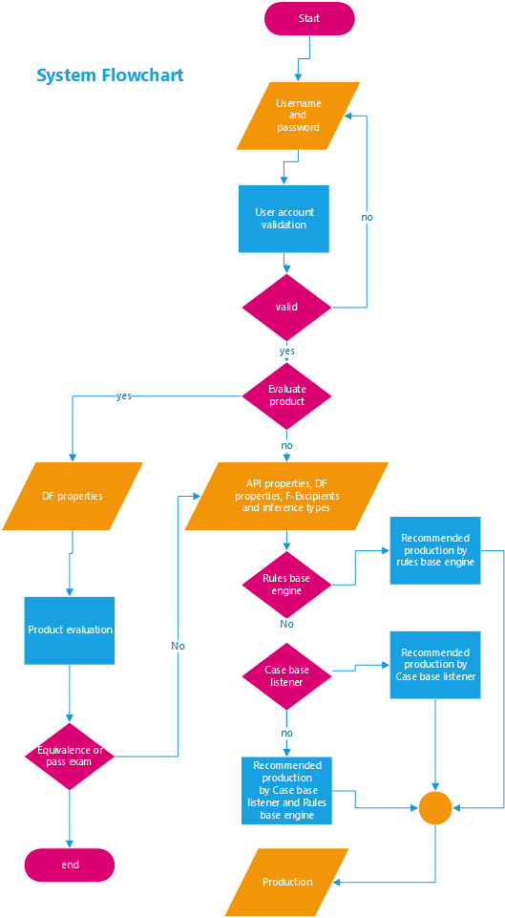

Figure 1: Drug reformulation workflow

## 2.2 Business Tools and Software Review

### 2.2.1 OXPIRT SYSTEM

##### Overview

The Ontology-base expert system for producing of a generic Immediate Release Tablet (OXPIRT) is an expert system designed to specifically assist with reformulating and producing a generic immediate release tablet [1]. A knowledge base relevant to generic tablet production is designed and represented in an ontology called Pharmaceutical Tablet Production Ontology (PTPO) [2], while a set of production rules is assigned to help with analyzing the conclusion in each condition. In the application, an inference engine is applied to simulate the reasoning process to pursue a conclusion from implicit information. A Pharmaceutical Tablet Production Ontology is illustrated in Figure 2

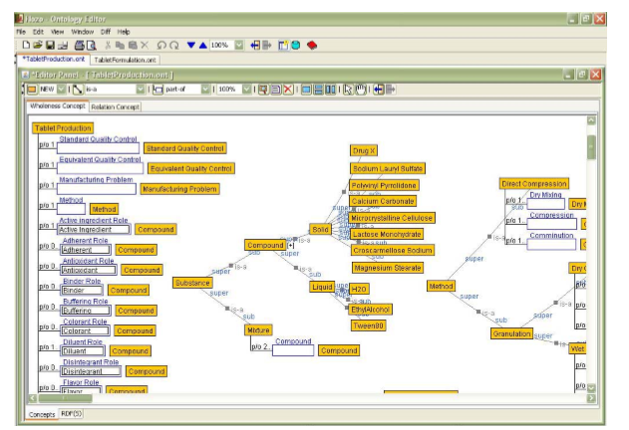

Figure 2: Pharmaceutical Tablet Production Ontology (PTPO) [2]

The pharmacists use this OXPIRT system for recommending a production of generic name drug that consist of a list of ingredients, quantity and a set of manufacturing instruction. The generic name drug will be reformulated until it is pharmaceutical equivalence to the original drug.

##### Pro

* The OXPIRT help to finding manufacturing similar with original drug.
* The OXPIRT help to reduce a statement of the process to find a generic drug manufacturing.
* The OXPIRT help to practice drugs producing.

##### Con

* OXPIRT is not support a smart phone device or a tablet computer.
* OXPIRT only reformulate original drugs as a tablet dosage form.
* OXPIRT use only Rule base engine to reformulate original drug.

### 2.2.2 Capsugel

#### Overview

Capsugel’s lipid expert system is aimed at supporting and accelerating lipid-based formulation development by leveraging a database of phase diagrams, now numbering several hundred, and continues to be expanded [3]. Capsugel is accessed by determining drug candidate solubility in a selection of individual excipients, a process can be complete in a matter of days and is supported by at least one month of stability data. Solubility values are then entered, along with the targeted dose and desired dosage form size.

Capsugel allow pharmacists can select the individual excipient and manufacturing. Capsugel will calculate from excipient and manufacturing for finding the best appropriate formula to lipid producing furthermore the system can show a solubility graph by 3d model. The 3-D ternary phase diagrams is illustrated in Figure 3.

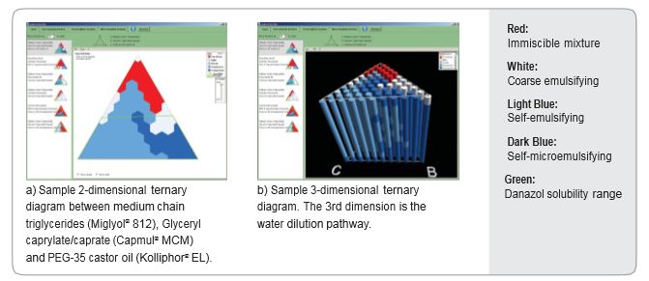

Figure 3: Lipid expert system output package: sample 2-, 3-D ternary phase diagrams, where the 3rd dimension represents the dilution pathway [3]

#### Pro

* The user can use Capsugel for producing a new drug with their own manufacturing and excipients.
* The user can reduce time-consuming to find appropriate formula.
* The user can see lipid solubility graph by 3D model.

#### Con

* Capsugel® is not a free program so, the user must pay a money for using it.

## 2.3 Technology review

### 2.3.1 PhoneGap

##### Overview

PhoneGap is an open source mobile application development framework. It uses for developing a Hybrid mobile application or mobile web application. PhoneGap was developed from open source Cordova project (Cordova by apache). It looks like general Hybrid mobile app development tools, but PhoneGap provides an application programming interface (API) that enables to access native operating system by using JavaScript. The PhoneGap collect a HTML5, css3 and JavaScript together and change web development technology to native application. The PhoneGap Architecture is illustrated in Figure 4.

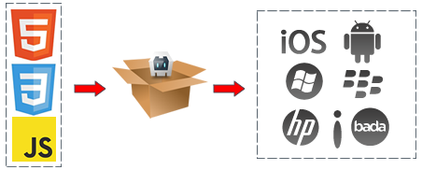

Figure 4: The PhoneGap Architecture

Developers can use PhoneGap API in native app for development such as an accumulator, camera contact and connection. The PhoneGap can provide transform a code to use for crossing platform devices such as IOS, Window phone, Android and etc. The PhoneGap application is developed using HTML, CSS, and JavaScript, but the deployed software of PhoneGap is binary application archive that can be distributed through standard application ecosystem. For example, IOS, application is changed to the IPA file format, for Android application the output is an APK file format, and for Window Phone the output is a XAP file.

##### Pro

* PhoneGap is powerful to port different operation system
* PhoneGap is HTML5 and JavaScript so, the developer do not study any new programming language to develop it.
* PhoneGap is open source, so there are many knowledge and document support developer such as PhoneGap document and stack overflow.

### 2.3.2 Inference engine

An Inference Engine is a tool from Artificial Intelligence. The first inference engines were components of expert systems. The typical expert system consisted of a knowledge base and an inference engine. The inference engine applied logical rules to the knowledge base and deduced new knowledge. This process would iterate as each new fact in the knowledge base could trigger additional rules in the inference engine. Inference engines work primarily in one of two modes: forward chaining and backward chaining. Forward chaining starts with the known facts and asserts new facts. Backward chaining starts with goals, and works backward to determine what facts must be asserted so that the goals can be achieved.

#### 2.3.2.1 Rule base engine

Rule base engine is a one of an inference Engine. A rule-based system is a set of "if-then" statements that use a set of assertions, to which rules on how to act upon those assertions are created [4]. They are often used in AI (artificial intelligence) and research. A rule base system uses a rule as knowledge representation for knowledge coded into a system. The definition of this system is mimicking the reasoning of human in solving intensive problem. The knowledge keep in a set of rules to tell what to do or what conclude in a different situation.

##### 2.3.2.1.1 JESS

##### Overview

JESS is a one of rule base engine for developing rule base system on java languages. JESS was developed by Ernest Friend-Hill at Sandia National Laboratories in Livermore. Developer can use JESS for develop an application that has the capacity to “reason”. JESS uses knowledge in form of declaratives rules [5]. JESS is small, light and one of fastest engine. It can provide developer accessing by jess API (Java languages). JESS includes a full-featured development environment based on the Eclipse platform.

##### Pro

* JESS is based on java languages. A java developer can understand JESS quickly.
* JESS provide framework as a java API. A developer easily implement JESS.
* JESS is small, light and fast. It will help an application working faster.

#### 2.3.2.2 Case-based Reasoning system

Case-based Reasoning (CBR), one of most successful applied subfield of AI, is the technical to solve on a solution of similar part problem of AI. CBR applies a reason technical which learning from human experience for developing a case study in the database to be knowledge that use to solving a problem. If the system discovers a new case study, the system learns and stores it to the database be experience for using in the future.

CBR System consists four processes [6].

* Retrieve: finding the most similar case or cases to be a case study.
* Reuse: taking the information and experience in the case study to solve a new problem.
* Revise: editing and checking the result from previously process.
* Retain: learning and storing a new case to be experience in database.

Case-based Reasoning has many framework for developing. Jcolibri is one of CBR framework.

##### 2.3.2.2.1 JCOLIBRI

##### Overview

JCOLIBRI is an object-oriented framework based on java languages for building CBR system. JCOLIBRI is open-source like CLAVIER and Selector application. The latest version is Jcolibri version 2.1. It has architecture to support two layers: one oriented to developers and other oriented to designers.

##### Pro

* JCOLIBRI is based on java languages. Java developers can understand Jcolibri very fast.
* JCOLIBRI provides framework like a spring framework. A developer easy to implement Jcolibri.

### 2.3.4 JSON

##### Overview

JSON (JavaScript Object Notation) is a lightweight data interchange - format. It based on a JavaScript programming languages. JSON is a text format that is completely language independent. Furthermore, it familiarly uses conventions to programmers of the C-family of languages, including C, C++, C#, Java, JavaScript, Perl, Python, and many others. These reasons make JSON to be an ideal data-interchange language [7].

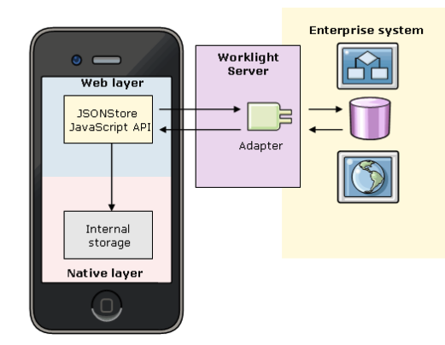

Figure 5: JSON mobile Architecture

From the JSON mobile architecture is illustrated in Figure 5. JSON store data by JavaScript API and keep the data at internal storage for using in native layer; furthermore, JSON can send the data to Enterprise system for using outside the mobile device by worklight server.

##### Pro

* JSON is based on JavaScript languages. The developer can understand it very fast.
* JSON can send to different platform such as JAVA C, C, C# Python and many other.

### 2.3.5 Spring framework

##### Overview

The Spring Framework is lightweight solution and a potential one-stop-shop for building enterprise application. Spring is designed to be non-intrusive [8]. It means there is no dependencies on the framework itself. Spring framework is a java platform that provide comprehensive infrastructure support for developing Java applications. Spring framework has become popular in the java community as alternative to, replacement, or even addition to the Enterprise JavaBean (ETB) model.

The Spring Framework consists of features organized into about 20 modules. These modules are grouped into Core Container, Data Access/Integration, Web, AOP (Aspect Oriented Programming), Instrumentation, and Test.

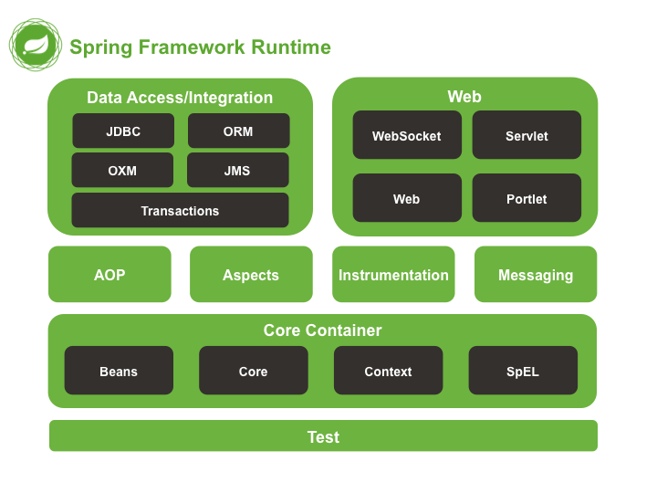

Figure 6: Spring Framework Runtime[8]**.**

From Spring Framework Runtime is illustrated in Figure 6.The Core Container part consists of the Core, Beans, Context, and Expression Language modules [8]. In part is The Core Container provide the fundamental parts of the framework, including the IOC and Dependency Injection features The data access/Integration provides integration layers for popular object-relational mapping APIs. The web part provide website basic function and MVC function. The AOP part provides an AOP Alliance-compliant aspect-oriented programming implementation. The Instrumentation provides class instrumentation support and class loader implementations to be used in certain application servers. Test supports the testing of Spring components with JUnit or TestNG.

##### Pro

* Spring can facility good programming by reducing the cost of programming to interfaces, rather than classes, almost to zero.
* Spring is good deigned, the most object in Spring applications have no dependency.
* Spring have many web that supporting a spring developer such as Spring website and stack overflow.

### 2.3.6 Mongo DB

##### Overview

MongoDB is an open-source document database that provides high performance, high availability and automatic scaling [9]. MongoDB stores a data as a structure. The data is kept like multidimensional array. The data structure composed of field and value pairs. Mongo DB documents are similar to JSON object.

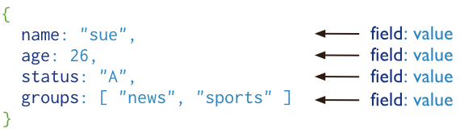

Figure 7: A MongoDB document.[8]**.**

From Figure 7, the value of field may include other documents array.

##### Pro

* MongoDB store data as GridFS. it will support the size of data changing.
* MongoDB support the Full Text, The developer can searching so fast with enormously data.
* MongoDB provides key and value for data query. So, the developers do not learn SQL statement.

## 2.4 Development Tools Review

### 2.4.1 Xcode

##### Overview

Xcode does more than ever to help you create high-quality apps. It automatically configures apps to use the latest Apple services, manages images in a unified asset catalog, and helps the developer design stunning interface for IOS 7 and OS X. It also makes it easy to analyze code, monitor performance, and test your apps, and with access to continuous integration built right in [10].

##### Alternative Tools

* Android SDK

#### The selection of this tool

PhoneGap uses Xcode for changing a mobile web application to native application.

### 2.4.2 Eclipse

##### Overview

Eclipse is a community for individuals and organization who wish to collaborate on commercially-friendly open source software. Its project are focused on building an open development platform comprised of extensible framework, tools and runtimes for building, deploying and managing software across the lifecycle. The Eclipse Foundation is a not-for-profit, member supported corporation that hosts the Eclipse projects and helps cultivate both an open source community and an ecosystem of complementary products and services.

##### Alternative Tools

* Netbean
* Intellij

#### The selection of this tool

The jCOLIBRI work on eclipse environment.

# Chapter Three | Quality Standard

## 3.1 Software Project Management In very small Entities (VSE)

The software is necessary for people living. It helps a science department to solve complicate problem easier, however software is not a human. It can be have an error anytime. If a system that failure software installed have effect to people, it make a huge problem to civil life and economy. For avoid this problem, software must have good management for manage software project to a good quantity and safety for people but In fact, there are many kind of software project management, it make a customer hard to decide which one is good or bad, therefore for make everyone in the software world have understand a same thing. The standard called ISO/IEC was developed.

ISO/IEC is an information security standard published by the International Organization of Standardization (ISO) and by the International Electro technical Commission (IEC).Its objective is to provide stakeholder with information about standardization, standards and related matters. It can help a software company deal with specialist issues, such as customer needs[2] and make more confidence to a customer. The ISO/IEC can separate in many form follow a size of a team project, therefore a suitable ISO/IEC for two people in a team is an ISO/IEC 29110.

Software Project Management in very small Entity with ISO/IEC 29110 focusing on Project management and software implementation as presented in figure 1. The purpose of the projects management process is to find and carry out in a systematic way the tasks of software implementation project which complies with the project’s objectives in terms of time, quality and cost. Project Management generates a Project Plan to for the software project. During the execution of the project changing Requests may cause revisions to the Project Plan. The project is the subject of Project Assessment and Control during the lifetimes of the project until the Software Implementation is complete and Project Closure occurs. Software Implementation (SI) produces a specified software system implemented as a software product or service. This process starts with the establishment of Software Requirements, after which Architectural and Detailed Design are produced. Software is the Constructed and verified using Integration and Test procedures. The final staged being product delivery to the customer [11].

Within ISO/IEC 29110, the purpose of the Project Management process is to establish and carry out in a systematic way the Tasks of the software implementation project, which allows complying with the project’s Objectives in the expected quality, time and costs. It is intended to be used by the VSE to establish processes to implement any development approach or methodology including, e.g., agile, evolutionary, incremental, test driven development, etc. based on the organization or project needs. The AN ISO/IEC 29110 Basic profile Process Diagrams is illustrated in Figure 8

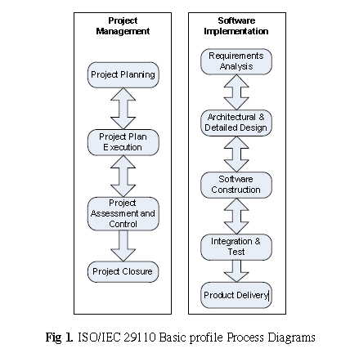

Figure 8: AN ISO/IEC 29110 Basic profile Process Diagrams[8]**.**

The four activities of the Project Management Process of ISO/IEC 29110-5-1-2 are:

• Project Planning - The primary objective of this process is to produce and communicate effective and workable project plans. This process determines the scope of the project management and technical activities, identifies process outputs, project tasks and deliverables, establishes schedules for project task conduct, including achievement criteria, and required resources to accomplish project tasks”.

• Project Plan Execution - To implement the actual work tasks of the project in accordance with the project plan. Ideally when the project plan has been agreed and communicated to all teams’ members, work of the development of the product, which is the subject of the project, should commence.

• Project Assessment and Control - purpose is to determine the status of the project and ensure that the project performs according to plans and schedules, within projected budgets and it satisfies technical objectives. This process includes redirecting the project activities, as appropriate, to correct identified deviations and variations from other project management or technical processes. Redirection may include re-planning as appropriate.

• Project Closure - typically involves releasing the final deliverables to the customer, handing over project documentation to the business, terminating supplier contracts, releasing project resources and communicating project closure to all stakeholders. Often a final step is to undertake a Post Implementation Review (post-mortem) to identify the level of project success and note any lessons learned for future projects.

This project Management software in very small entity (VSE) is important in every project that have a small member in a group, because it make a software project to successful in a time moreover, it help to small team working is more standard and efficiency. [11]

• Software development process – the software engineering use spiral model, because the advantage of spiral model is support documentation control and high risk of the program. The spiral model appropriate with The ontology base expert system for generic drug production of pharmaceutical dosage form because, In this project there are some risk that make program working error such as the ontology of pharmaceutical is not correct or reformation working wrong. And the document of this project must control by person because, In each progress submission the software engineering will send the document about project development progress report.

# Chapter Four | Project Plan

## 4.1-Motivation

The price of original drugs, which is under patent protection, is always expensive because of research and development costs. So this reasons make poor people, in developing countries, cannot pay for curing their sickness or disease. For solve this problem, the local pharmaceutical corporations try to develop a new drug manufacturing that call reformulating drugs into a generic version after the patent protection expired.

The pharmaceutical formulation process is a highly specialize task requiring specific domain knowledge and often years of experience. Expert system derived from research into artificial intelligence support the efficient formulation of products and therefore increase productivity, consistency and quality [12].

Follow the issue above, Ontology-based Expert System for a Generic Drug Production of Pharmaceutical Dosage Forms can help an inexperienced industry pharmacists to reproduce a generic drug in the right way and the right time.

## 4.2-Aim

The aim of this project is to develop mobile application on Tablet computer. Ontology-based Expert System for a Generic Drug Production of Pharmaceutical Dosage Forms recommend a solution for reformulating an original drug into a generic version. The generic production receives a pharmaceutical value and shows result as a drug formula, manufacturing and excipients. The experience pharmacist can use Ontology-based Expert System for a Generic Drug Production of Pharmaceutical Dosage Forms for reformulating drug.

## 4.3-Objective

* To recommend a generic production that consist of a formula and its instructions.
* To evaluate the generic drug production comparing with the original drug.
* To suggestion the generic production, which is not equivalent to the original drug, until it equivalent to its original.

## 4.4-System Architecture

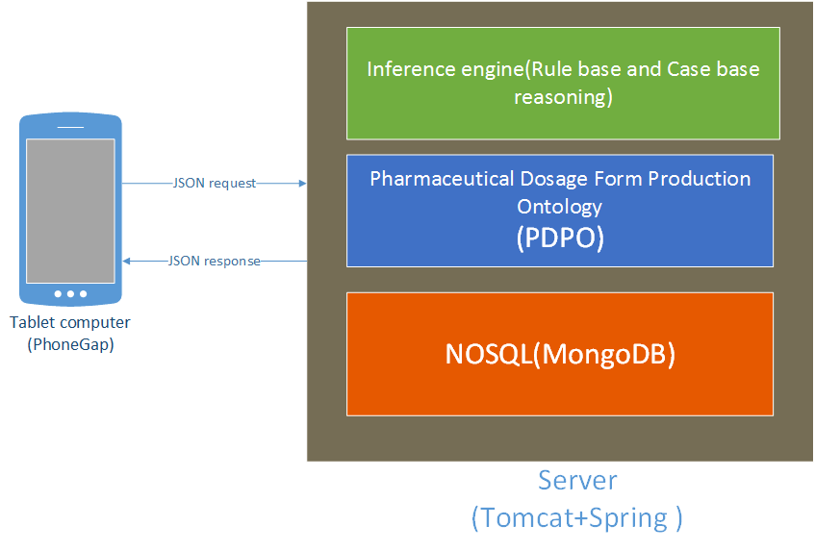

Figure 9: System Architecture.

Figure 9 show the system architecture of Ontology-based Expert System for a Generic Drug Production of Pharmaceutical Dosage Forms. Firstly, the system receives an input data from a user via tablet computer. Then it send the data to the server in JSON format. After that, the system on server will recommend an appropriate solutions using rule base technique and/or case base reasoning. Finally the system returns a drugs reformulation with manufacturing and excipients to the user.

## 4.5- Deliverables and Limits

### 4.5.1 Deliverables

#### 4.5.1.1 Architecture Overview

From the system architecture on Figure 8, Ontology-based Expert System for a Generic Drug Production of Pharmaceutical Dosage Forms can be divided into many subsystem such as the user management system, the rule base system, the case base reasoning system, hybrid reasoning system and the pharmaceutical tablet production on ontology. The server side is develop on JAVA programming and with apache server. The structure of architecture overview is illustrated in Figure 10

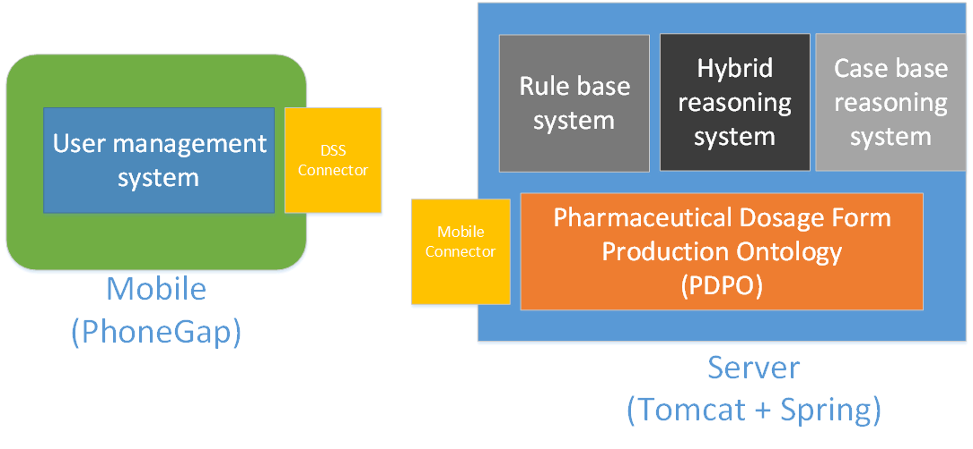

Figure 10: System Architecture overview

The subsystem can group into two main parts. The first one is a mobile part, and the second is a server part.

##### Mobile Part

* **Feature 1 : User management system**

There are two types of users in Ontology-based Expert System for a Generic Drug Production of Pharmaceutical Dosage Forms. The first one is experience pharmacists. This user uses the system for evaluating generic drugs production comparing with the original drug production. The experience pharmacists also use the system for suggested an appropriate manufacturing and excipients to reformulate a drug and they can create and/or add a new case by themselves. The second is inexperience pharmacists. This user uses the system similar with experience pharmacists, but they cannot add add/or create any of a new pharmaceutical case.

##### Server part

* **Feature 2 : Rule base system**

Rule base system is one part of inference engine that using for suggesting the reformulate an original drug as a generic version. Rule base system can decide a drug reformulating by “rule “. The rule is come from a set of pharmaceutical knowledge that call PDPO (Pharmaceutical dosage form production ontology). The rule base system receive a pharmaceutical value and show an appropriate result as a manufacturing and excipient to the user.

* **Feature 3 : Case base reasoning system**

Case base reasoning system is one part of inference engine like a Rule base system. Ontology-based Expert System for a Generic Drug Production of Pharmaceutical Dosage Forms uses a case base reasoning system for reformulating an original drug and comparing the generic drug production with original drug production. The experience pharmacists can use the case base reasoning system for creating and adding a new case into the system. The new case base used to reformulate an original drug like existing case base.

* **Feature 4: Hybrid reasoning system**

Hybrid reasoning system is an inference engine that combine with Case base reasoning and Rule base system. The system is suggest to reformulate an original drug into a generic version. The pharmacists can use the hybrid reasoning system for creating and adding a new case into the system like Case base reasoning system.

* **Feature 5 : Pharmaceutical Dosage Form Production Ontology(PDPO)**

Pharmaceutical dosage form production ontology is kept as set of knowledge. The rule base and the case base reasoning use PDPD for calculating an appropriate reformulate drugs the reformulate an original drug as generic version.

* **Feature 6 : DSS connector**

DSS connector is a system at mobile part which sending and receiving a data between users and a server. DSS connector receive a data from a user interface and send data to PDPO for find a drug reformulation Additionally, DSS connector can receive a result from PDPO and show it to a user.

* **Feature 7 : Mobile connector**

Mobile connector is a system at server part which sending and receiving a data between users and a server. Mobile connector receive an input data from mobile part and send data to PDPO for suggesting a reformulate original drugs as generic drug production; furthermore Mobile connector sends a result to mobile part.

#### 4.5.1.2 Documents

* Proposal
* Project Plan
* Software Requirement Specification
* Software Design Document
* Testing Document
  + Test Plan
    - Unit Test Plan
    - System Test Plan
  + Test Report
    - Unit Test report
    - System Test report
* 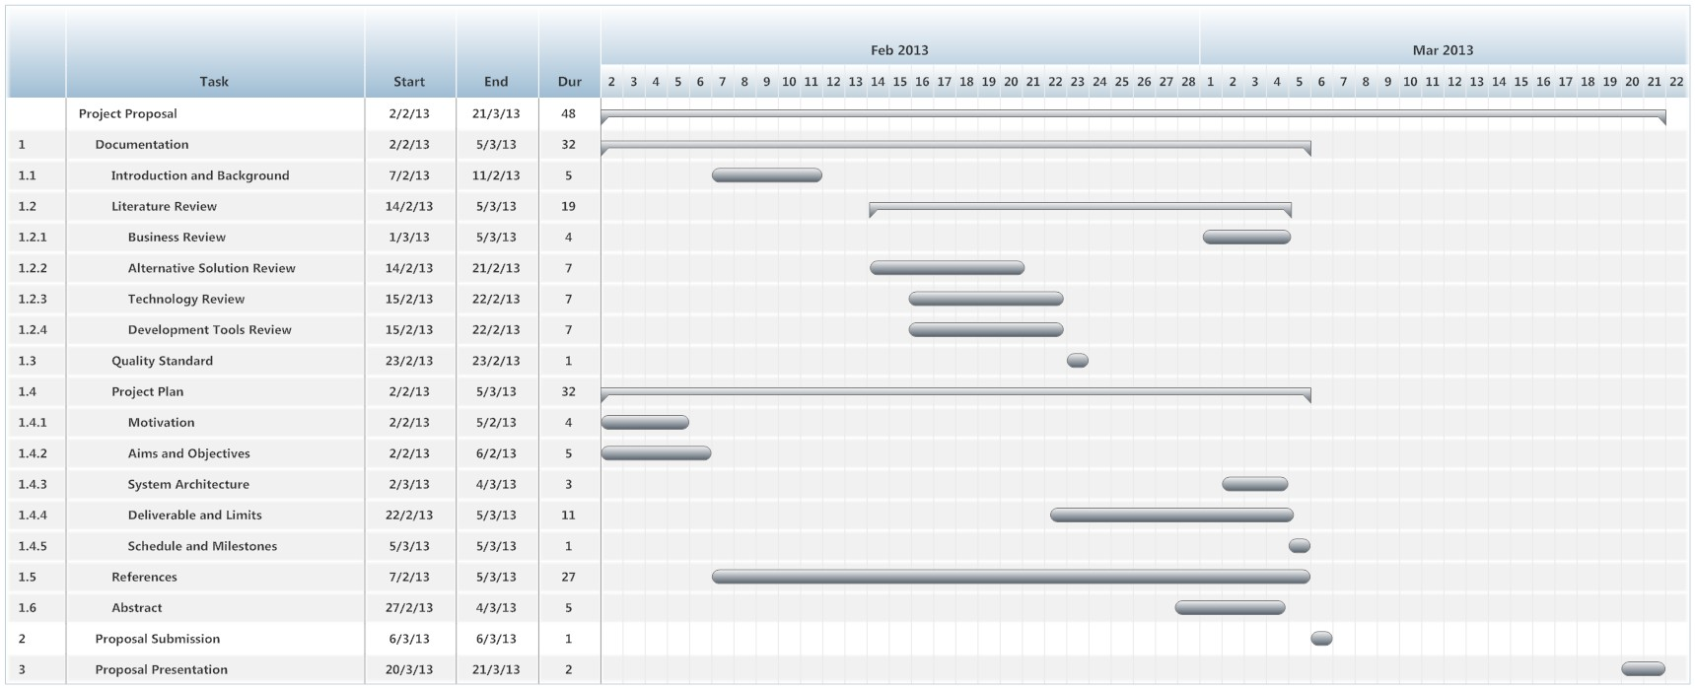Traceability Record
* 1 DVD stores client source code, relate file, all documents and poster files in PDF format.
* 1 project poster.

### 4.5.2 Limit

* The user require a Tablet computer and internet connection.
* Ontology-based Expert System for a Generic Drug Production of Pharmaceutical Dosage Forms is appropriated with a person who has a pharmacy knowledge.

## 4.6 Future work

* The system can support responsive web.
* The system can support the other dosage forms such as cream, gel.

## 4.7 Schedule & Milestones

The schedule and milestones of Ontology-based Expert System for a Generic Drug Production of Pharmaceutical Dosage Forms. During period of time, there are work terminologies. And the description is shown below that:

* **Feature 1 : User management system**
* **Feature 2 : Rule base system**
* **Feature 3 : Case base reasoning system**
* **Feature 4 : Hybrid reasoning system**
* **Feature 5 : Pharmaceutical Dosage Form Production Ontology(PDPO)**
* **Feature 6 : DSS connection system**
* **Feature 7 : Mobile connector**

### 4.7.1 Schedule Plan

|  |  |  |  |
| --- | --- | --- | --- |
| Milestone | Task | Milestone Criteria | Planned date |
| 1 | Proposal | * Topic defined | February |
| 2 | Proposal | * Proposal reviewed * Proposal submitted * Proposal presentation | March |
| 3 | Progress Report I | * Software requirement specification * Feature 2 , Feature 5,Feature 7 * Software design document * Test Plan * Feature implemented * Feature test report * Traceability record progress I * Progress report I submitted * Progress report I presentation   STMS-Proposal Milestone.jpg | May |
| 4 | Progress Report II | * Feature 1, Feature 3 and Feature 6 * Software design document * Test Planed * Feature implementation * Feature test report * Traceability record progress II * Progress report II submitted * Progress report II presentation | July |
| 5 | Progress Report III | * Feature 4 * Software design document * Test Planed * Feature implementation * Feature test report * Traceability record progress III * Progress report III submitted * Progress report III presentation | September |

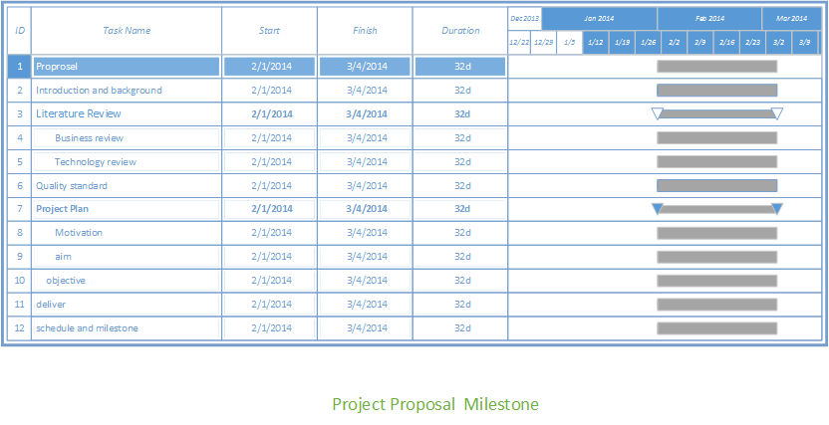

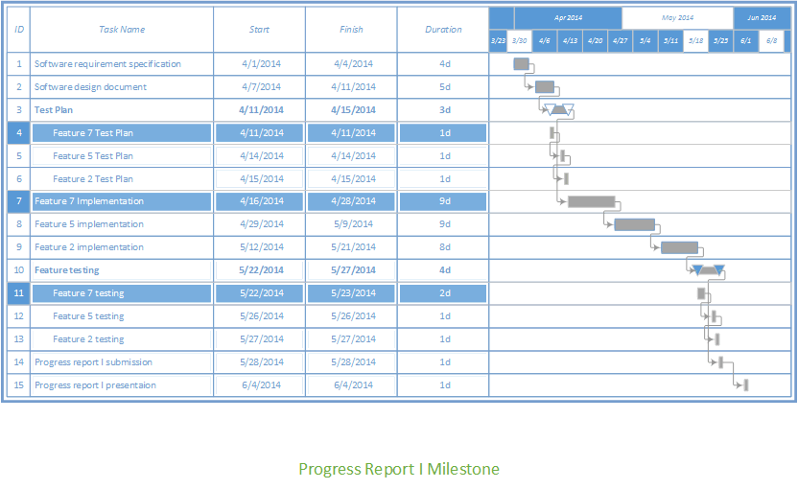

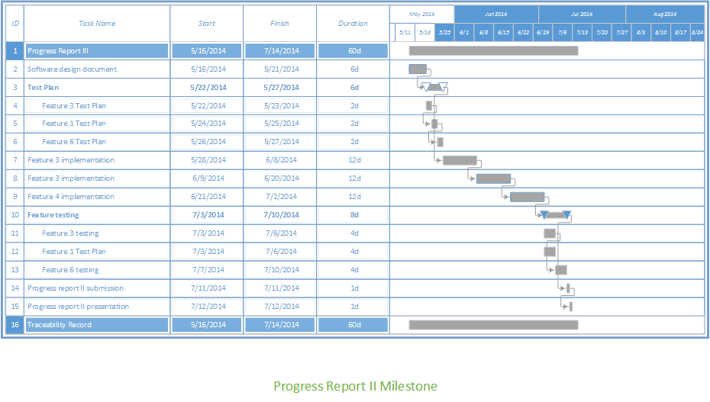

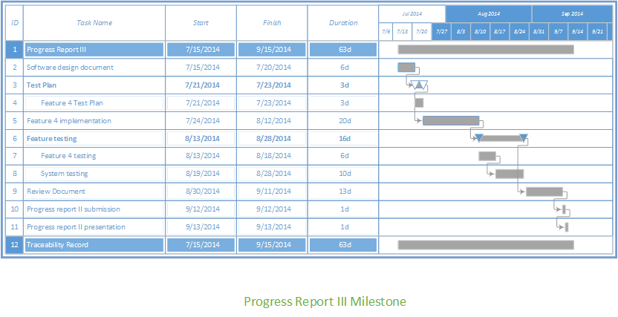

# Chapter Five | Reference

|  |  |
| --- | --- |
| [1] | D. J. Aguilar, Formulation tools for pharmaceutical development, Woodhead publising, 2013. |
| [2] | P. L. a. T. S. Nopphadol Chalorttham, “Development of Generic Drug Tablet Production Expert System,” *Development of Generic Drug Tablet Production Expert System,* vol. 1, pp. 1-6, 2011. |
| [3] | P. Eduardo Jule, “Accelerating Lipid-Based Drug Formulation Through Application of an Expert System”. |
| [4] | webopedia, “webopedia,” rule-based system, [Online]. Available: http://www.webopedia.com/TERM/R/rule_based_system.html. [Accessed 1 3 2014]. |
| [5] | E. J. Friedman-Hill, “Jess,” JESS, 5 November 2008. [Online]. Available: http://www.jessrules.com/jess/docs/71/index.html. [Accessed 27 Feburary 2014]. |
| [6] | J. A. R.-G. B. D.-A. P. González-Calero, “GAIA – Group of Artificial Intelligence Applications,” 16 September 2008. [Online]. Available: http://gaia.fdi.ucm.es/files/people/juanan/jcolibri/downloads/tutorial.pdf. [Accessed 1 Feburary 2014]. |
| [7] | JSon, “Json,” 03 March 2014. [Online]. Available: http://json.org/. [Accessed 04 March 2014]. |
| [8] | Rod Johnson , Juergen Hoeller , Keith Donald , Colin Sampaleanu , Rob Harrop , Thomas Risberg , Alef Arendsen , Darren Davison , Dmitriy Kopylenko , Mark Pollack , Thierry Templier , Erwin Vervaet , Portia Tung , Ben Hale , Adrian Colyer , John Lewis , Co, “Spring Framework Reference Documentation,” Spring Framework, 2013. [Online]. Available: http://docs.spring.io/spring/docs/4.0.2.RELEASE/spring-framework-reference/htmlsingle/#overview. [Accessed 2 Feburary 2014]. |
| [9] | MongoDB, “MongoDB,” 2013. [Online]. Available: http://docs.mongodb.org/manual/core/introduction/. [Accessed 3 March 2014]. |
| [10] | a. developer, “developer,” xcode, 2014. [Online]. Available: https://developer.apple.com/xcode/. [Accessed 3 March 2014]. |
| [11] | R. V. O. C. Y. Laporte3, “Software Project Management in Very Small Entities,” p. 2. |
| [12] | Raymond C. Rowe, Ronald J. Reberts, “Artificail Intelligence in pharmaceutical product formulation: knowledge-based and expert system,” *PSTT,* vol. 1, no. 4, pp. 153-159, 1998. |
| [13] | t. f. e. Wikipedia, “Rule-based system,” 1 January 2014. [Online]. Available: http://en.wikipedia.org/wiki/Rule-based_system. [Accessed 28 Feburary 2014]. |
| [14] | G. L.-A. &. T. S. T. C. Community., “Sublime Text,” 2013. [Online]. Available: http://www.sublimetext.com/. [Accessed 3 March 2014]. |